[[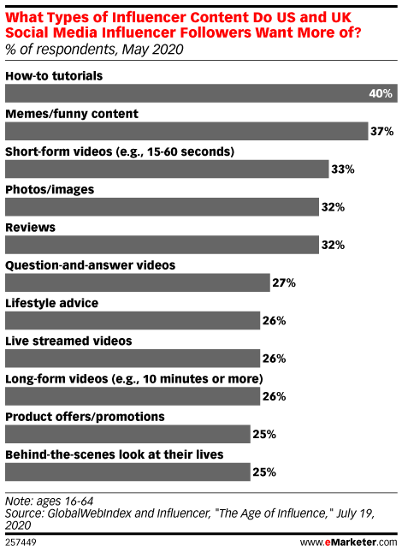](https://www.emarketer.com/api/RedirectAsset?a=chart&r=263336)](https://www.emarketer.com/api/RedirectAsset?a=chart&r=263336" \t "_blank)