HO NGUYEN NGOC – GRADUATION PAPER IN ENGLISH LINGUISTICS - 2021

DUY TAN UNIVERSITY
FACULTY OF ENGLISH

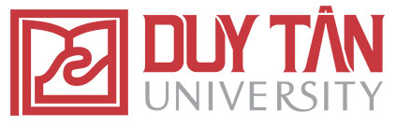

HO NGUYEN NGOC

AN ANALYSIS OF THE SUGGESTED
TRANSLATION OF THE REPORT ON DIGITAL MUSIC IN 2020

GRADUATION PAPER IN ENGLISH LINGUISTICS

Ghi chú: Bìa ngoài
DA NANG, 2021
DUY TAN UNIVERSITY
FACULTY OF ENGLISH

GRADUATION PAPER

AN ANALYSIS OF THE SUGGESTED TRANSLATION OF THE REPORT ON DIGITAL MUSIC IN 2009

Major: English for Translation - Interpretation

SUPERVISOR : TRAN THI MINH GIANG, Ph.D
STUDENT : HO NGUYEN NGOC
CLASS : K23NAB
STUDENT CODE: 2320310610

DA NANG, 2021
Ghi chú: Bìa trong

