HO NGUYEN NGOC – GRADUATION PAPER IN ENGLISH LINGUISTICS - 2021

DUY TAN UNIVERSITY
FACULTY OF ENGLISH

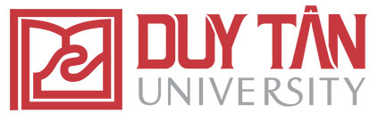

HỒ NGUYÊN NGỌC

AN INVESTIGATION INTO CUSTOMER CARE SERVICE AND SOME SOLUTIONS TO ATTRACTING INTERNATIONAL VISITORS TO THE SAGATEX VIETNAM CO., LTD

GRADUATION PAPER IN ENGLISH LINGUISTICS

Ghi chú: Bìa ngoài
DA NANG, 2021
DUY TAN UNIVERSITY
FACULTY OF ENGLISH

GRADUATION PAPER

AN INVESTIGATION INTO CUSTOMER CARE SERVICE AND SOME SOLUTIONS TO ATTRACTING INTERNATIONAL VISITORS TO THE SAGATEX VIETNAM CO., LTD

Major: English for Tourism and Hospitality

SUPERVISOR : MAI LAN THI, M.A
STUDENT : HỒ NGUYÊN NGỌC
CLASS : K23 NAB5
STUDENT CODE: 232032111369

DA NANG, 2021
Ghi chú: Bìa trong

